Jerome Allen

6/9/2017

Subsystem One Pager

**Mission:** Create a design for a falling drone that will take pictures determined by different altitudes. The drone should be designed in such a way where it can take clear aerial pictures to help gain information for natural disaster first responders.

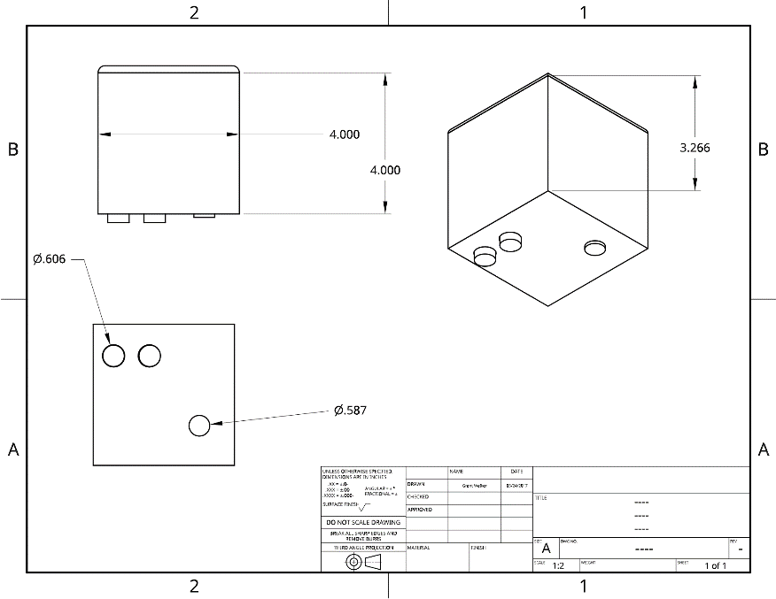**Location:** Valor Christian School International, Beaverton OR 97006

**Type of chassis:** Structure of the chassis is a

Simple box design with three holes made to

fit the exact size of the sensor and camera.

The box was 3D printed made of PLA plastic.

Design did not implement sufficient landing

padding. Hot-glued pieces of foam was placed

at each bottom corner to ensure soft a soft

landing for each drop.

**Failures:** Structural failures included issues with servo placement, resulting in relocating the camera to outside of chassis, hot glued to the bottom. Also, many issues appeared when working out the coding portion of the drone, problems consisted of timing issues, specifically when the servo should hit the camera button, and calibration problems. The foam landing did not hold up as well as the group planned as a failed drop made one of the pieces of foam to crack.